CPU
Processor Organization:
1. Register based CPU organization
2. Accumulator based CPU organization
3. Stack based CPU organization

Accumulator based CPU organization:
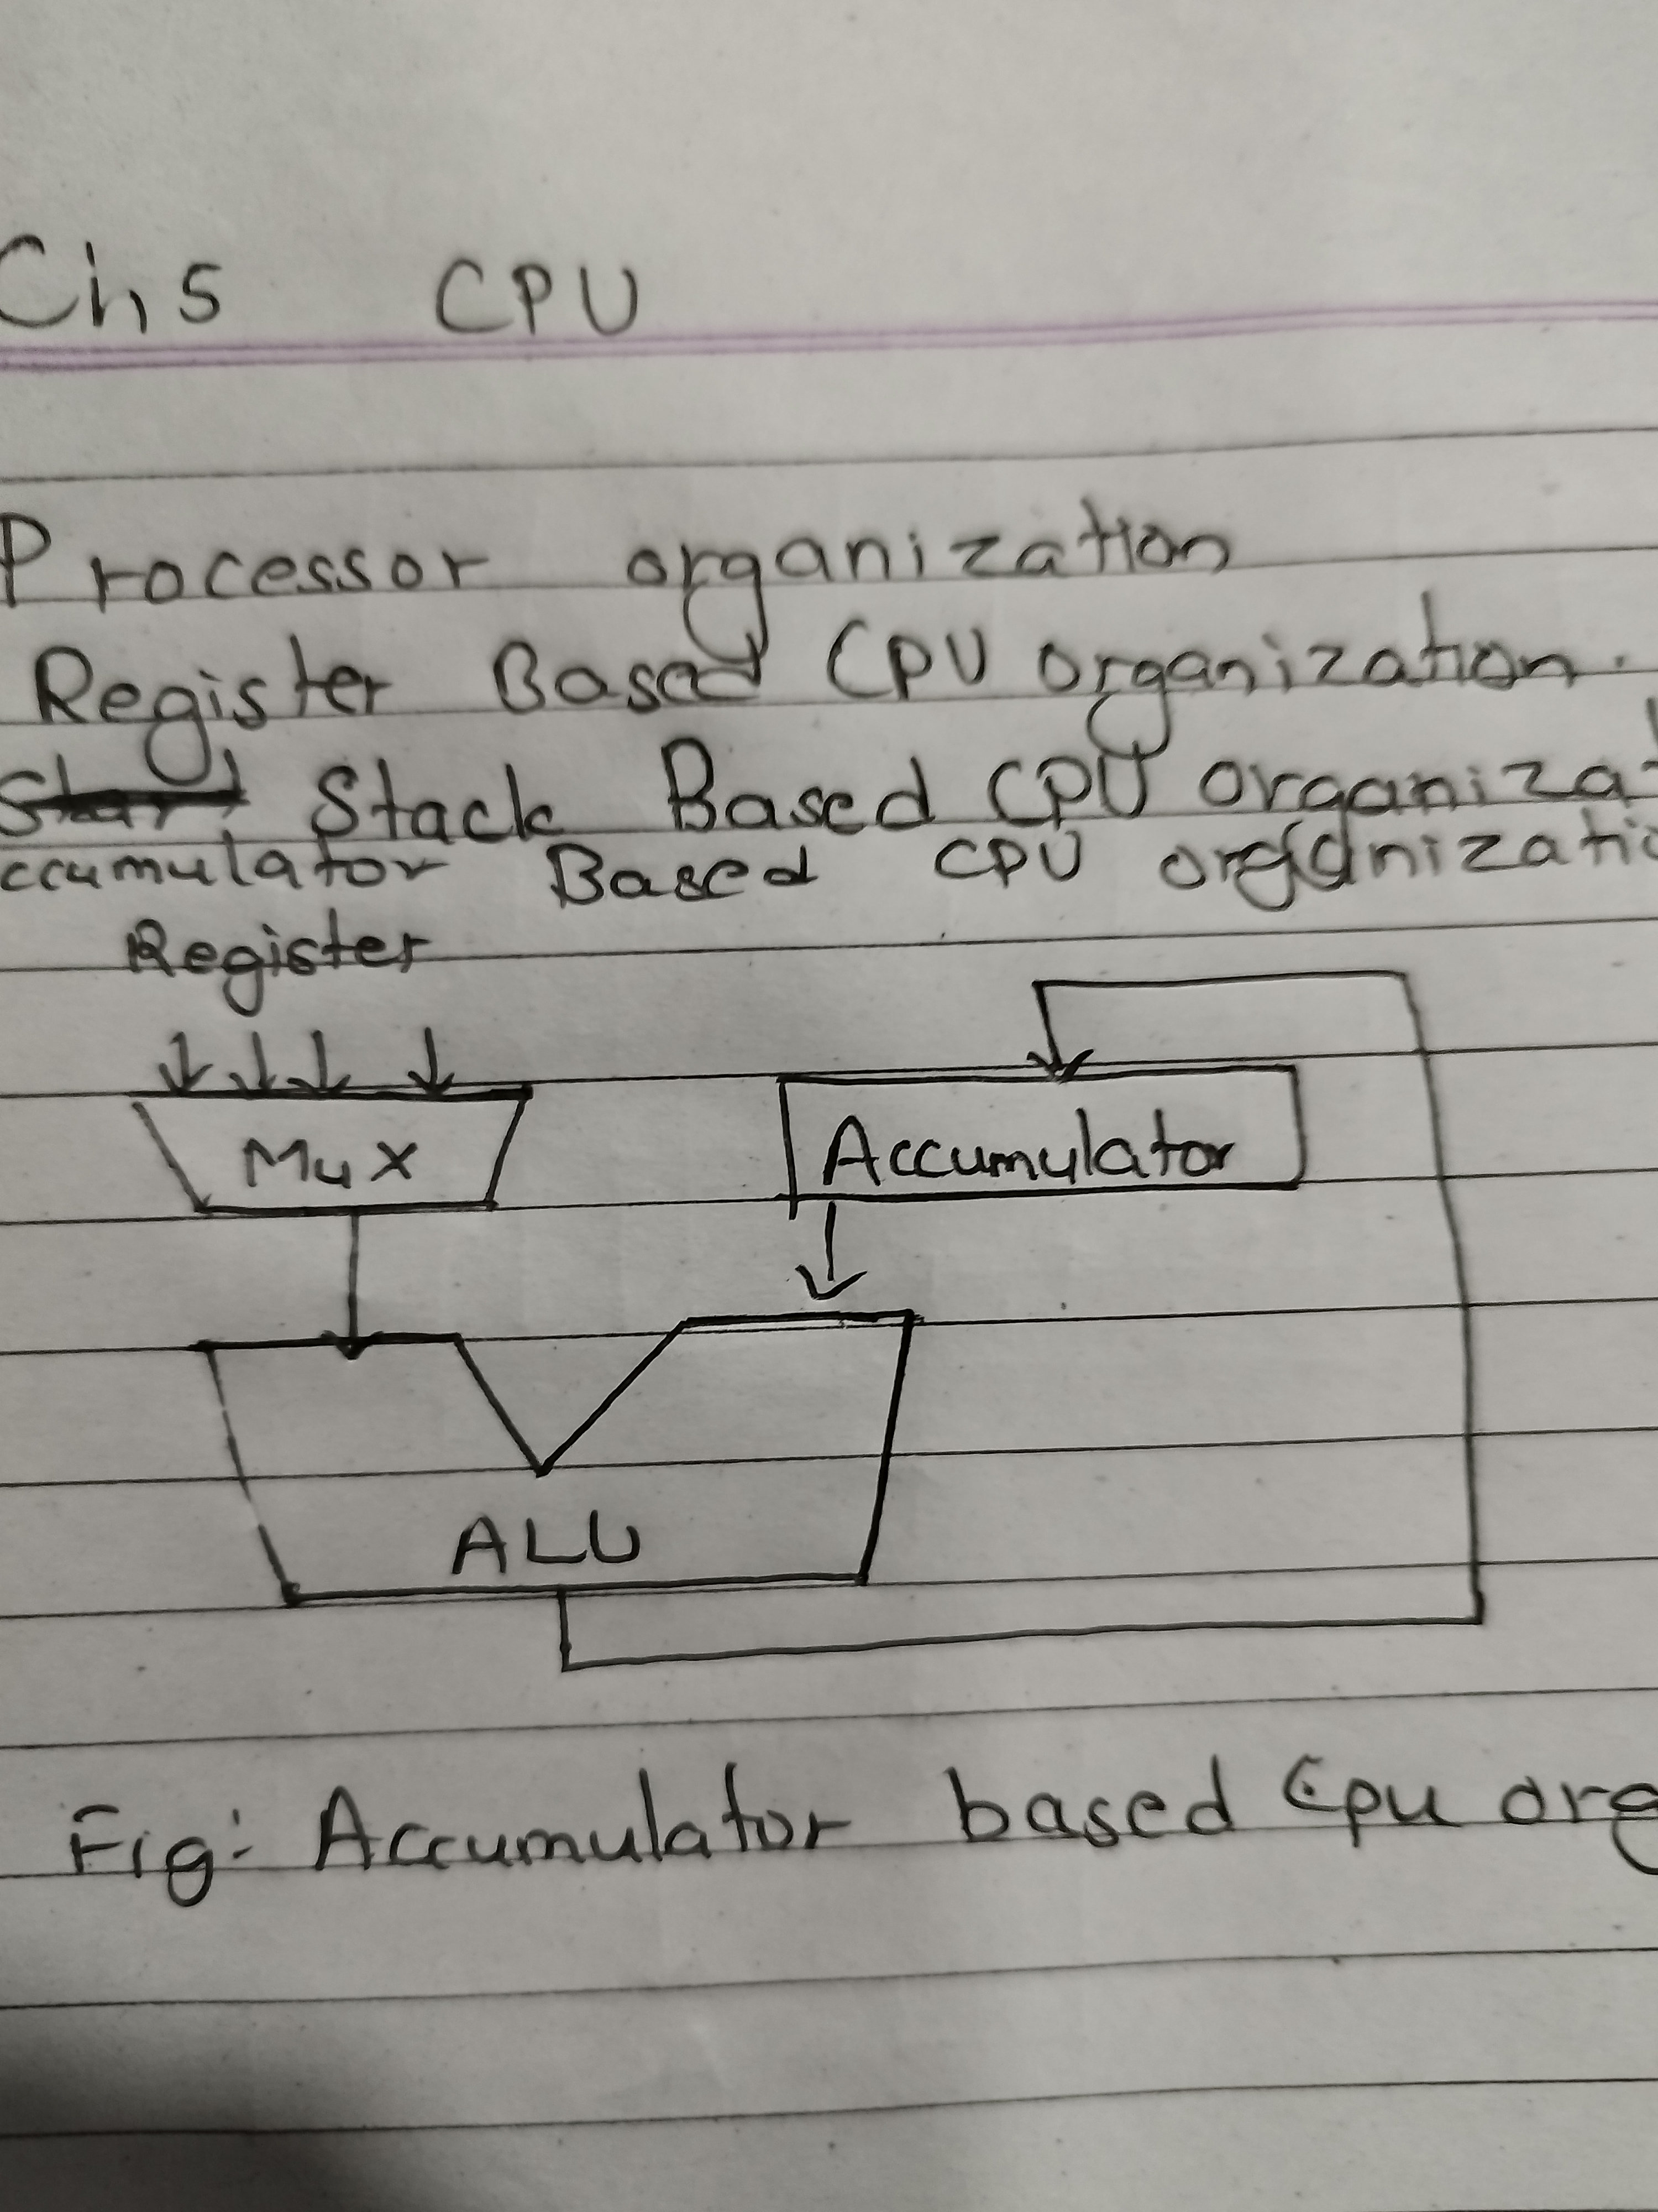
Stack Based CPU organization:
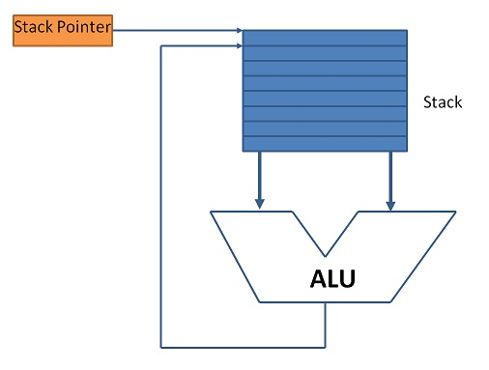

Instruction Format:
1. Three address instruction format
→ MUL R1 ,A ,B // R1 ← M[A] * M[B]

2. Two address instruction format
→ MOV R1 ,A // R1← M[A]
→ MUL R1 ,B // R1 ← R1 * M[B]

3. One address instruction format
→ MUL R1 // A_{C} ← A_{C} * R1

4. Zero address instruction format

